**CDS view**

1) Open ABAP perspective

2) Add Package created in se80 to favorite package.

Favorite Package-New-ABAP Package-ZGT_PACK

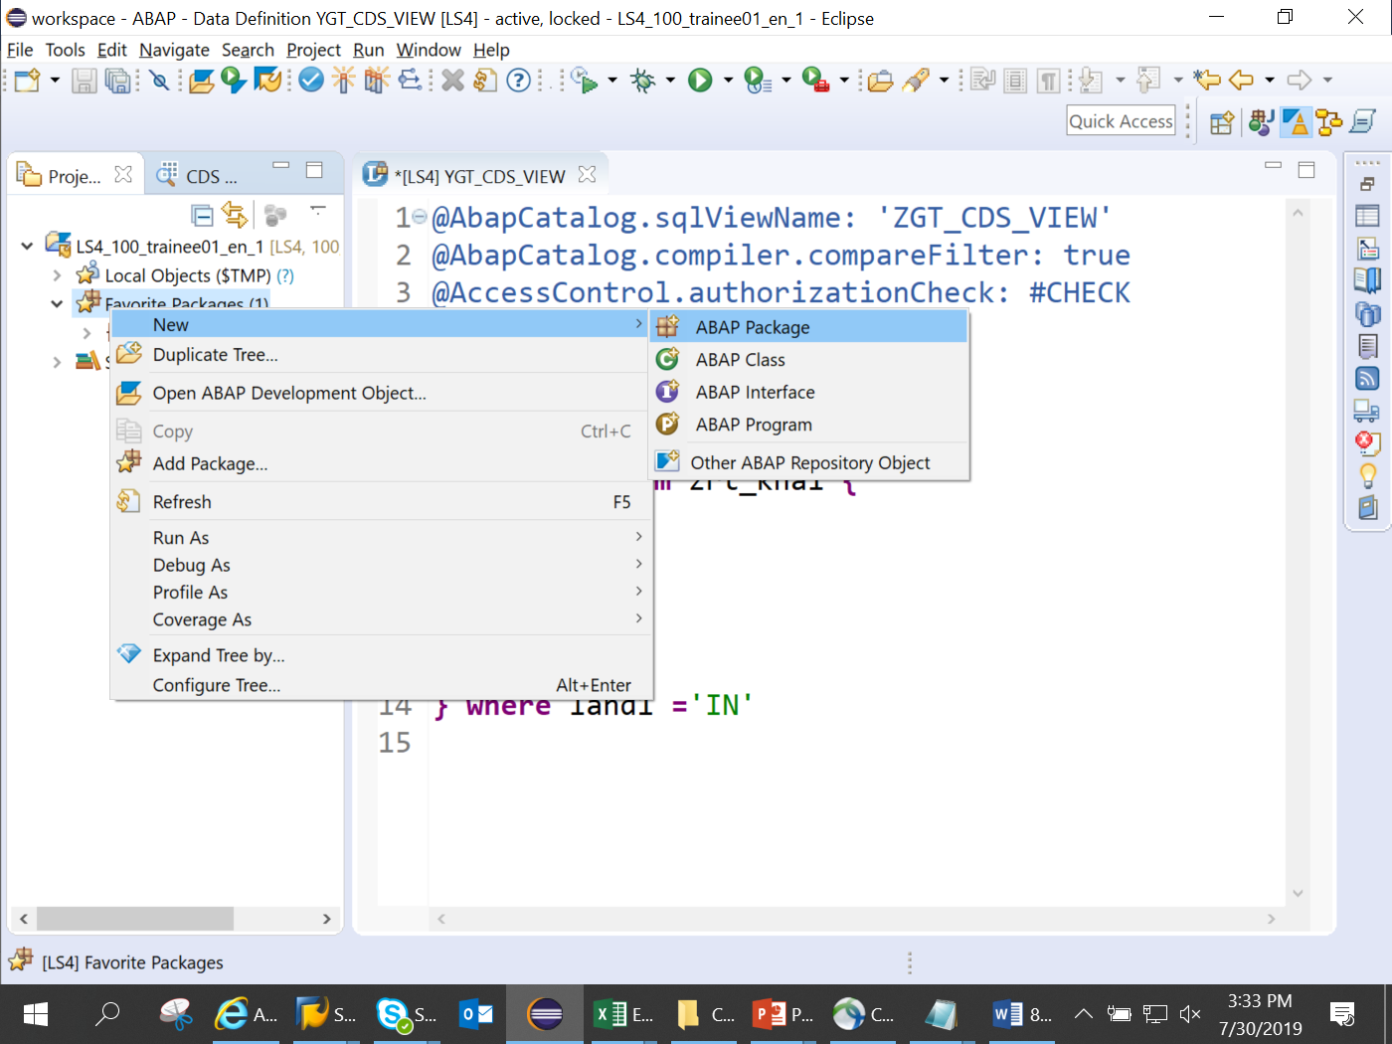

3) Right click on package ZGT_PACK -New- Other Repository Object-core data services-data definition

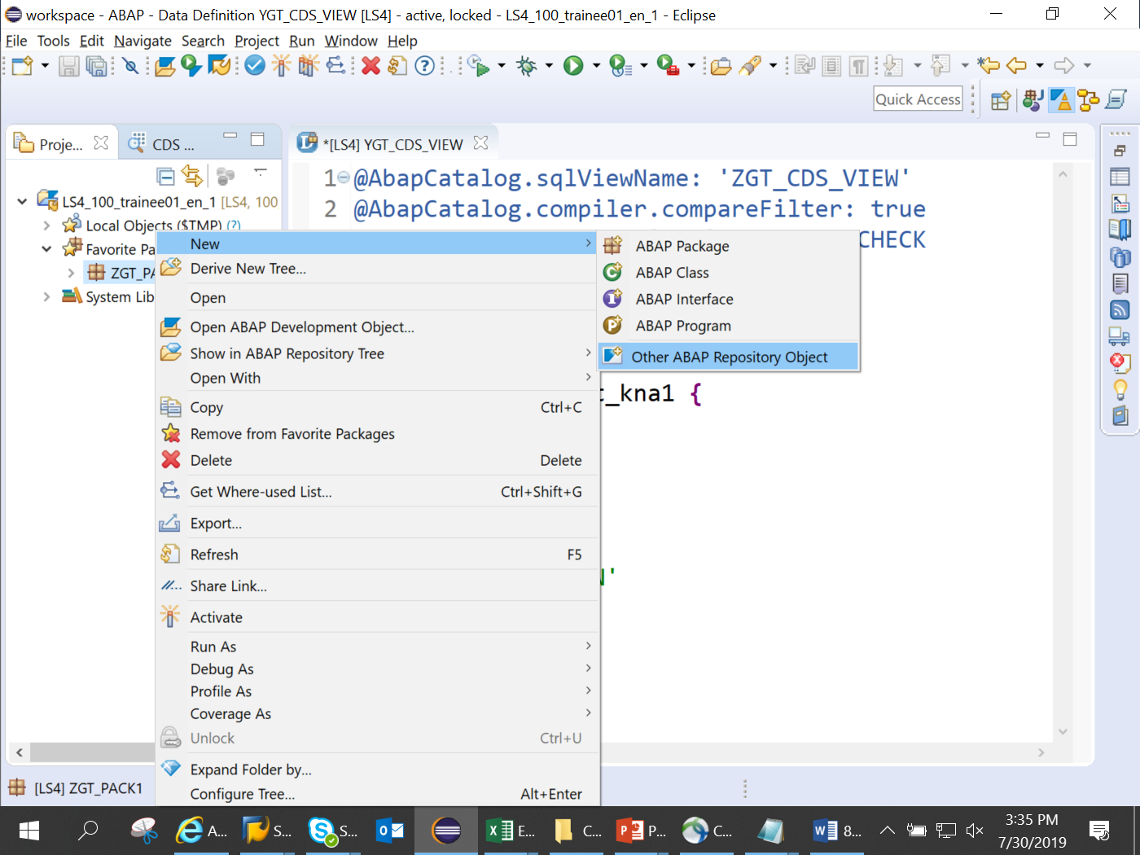

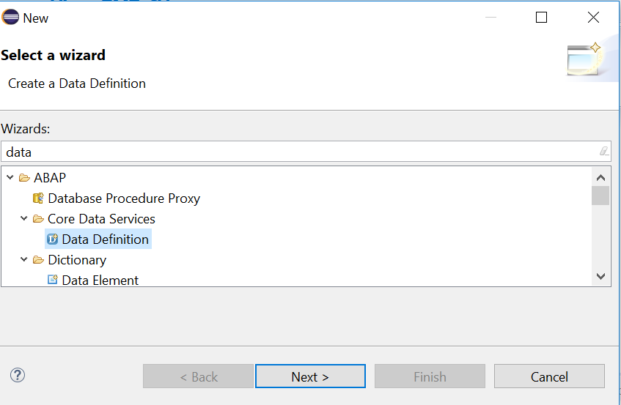

4) Give a name to CDS view starting with Y.

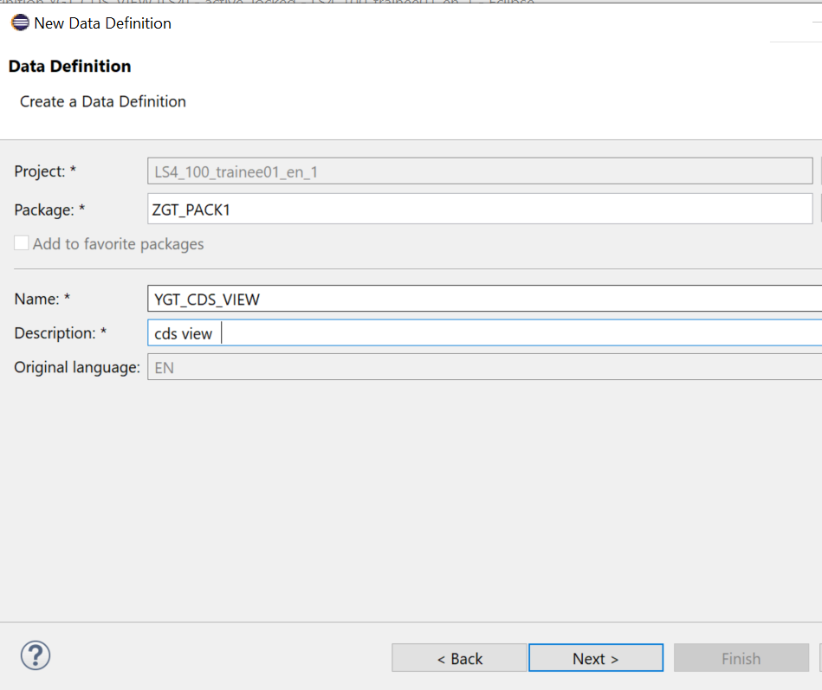

5) choose your Transport request

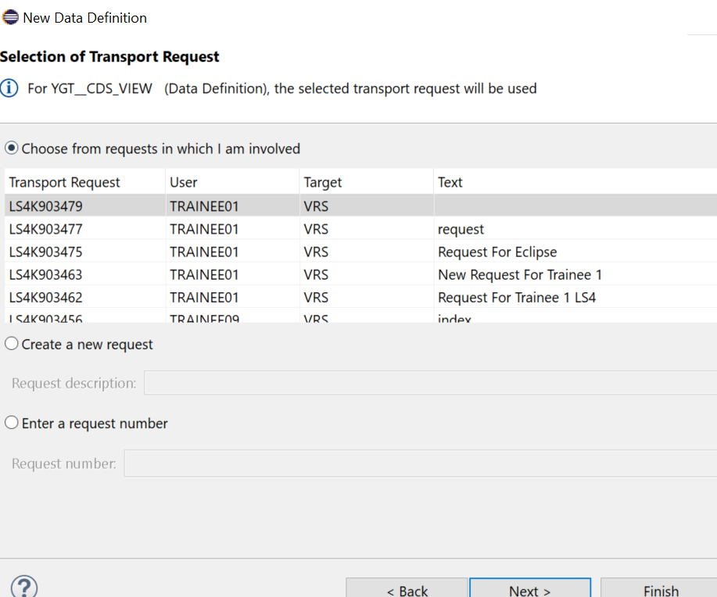

6) Choose Define view (1st option) - Finish

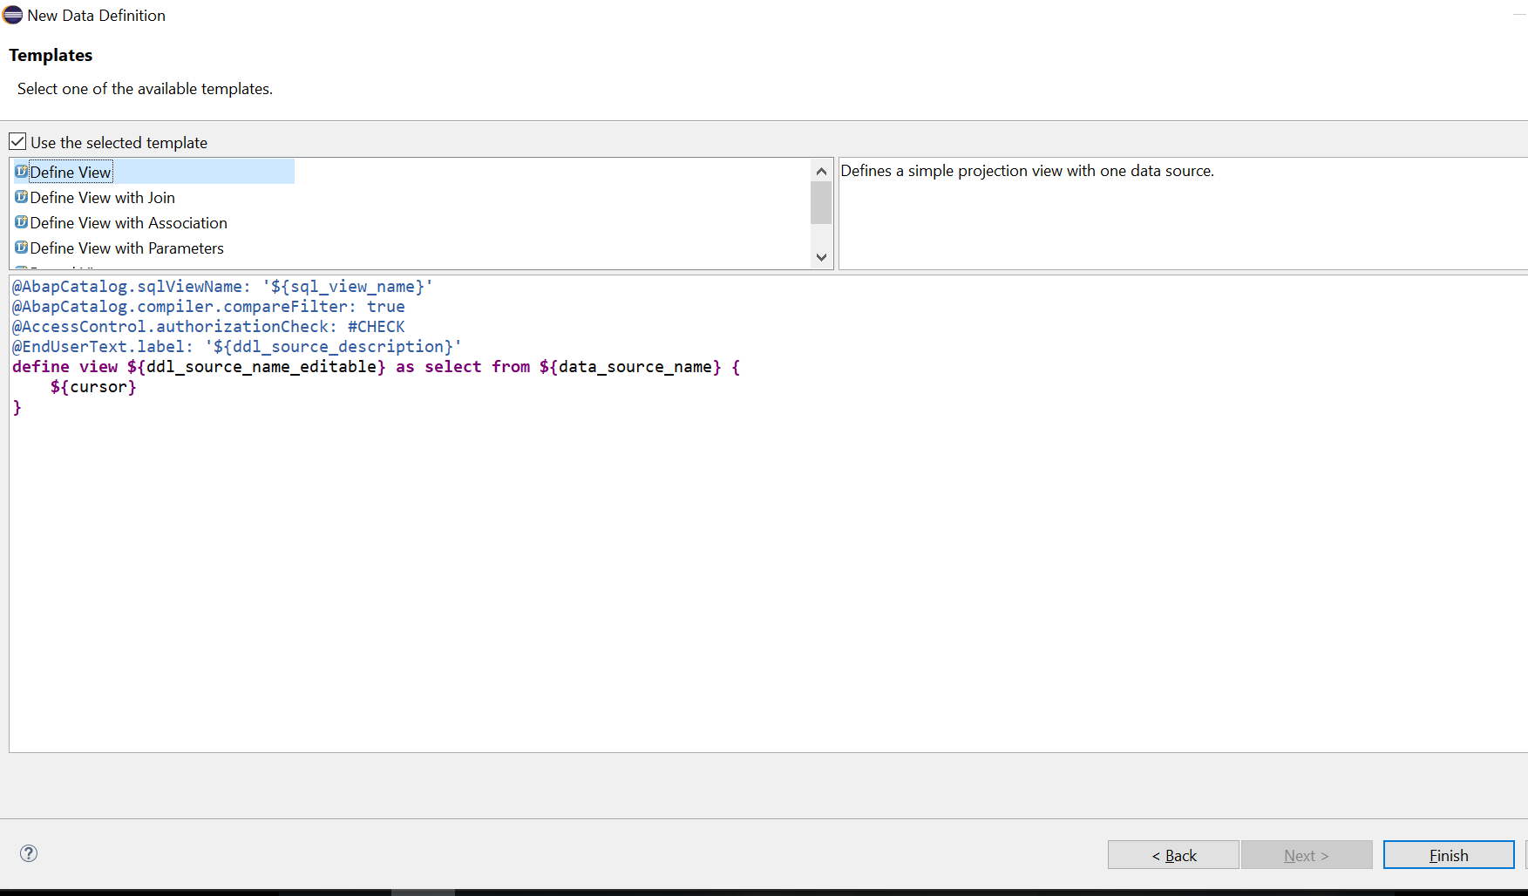

7) Change description and SQL view name to starting with y or Z and add code as shown

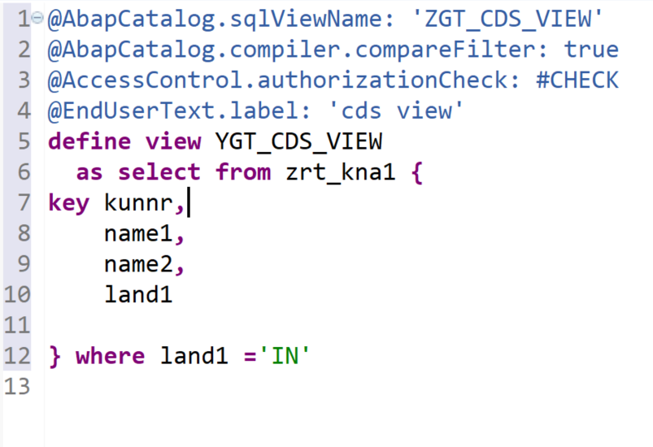

Note

ZGT_CDS_VIEW is the dictionary view and can be checked in SE11

Whereas YGT_CDS_VIEW is the ABAP view/DDL source and can be checked in ABAP perspective- fav package- zGT_PACK-core data services-data definition-YGT_CDS_VIEW

8) Save and Activate

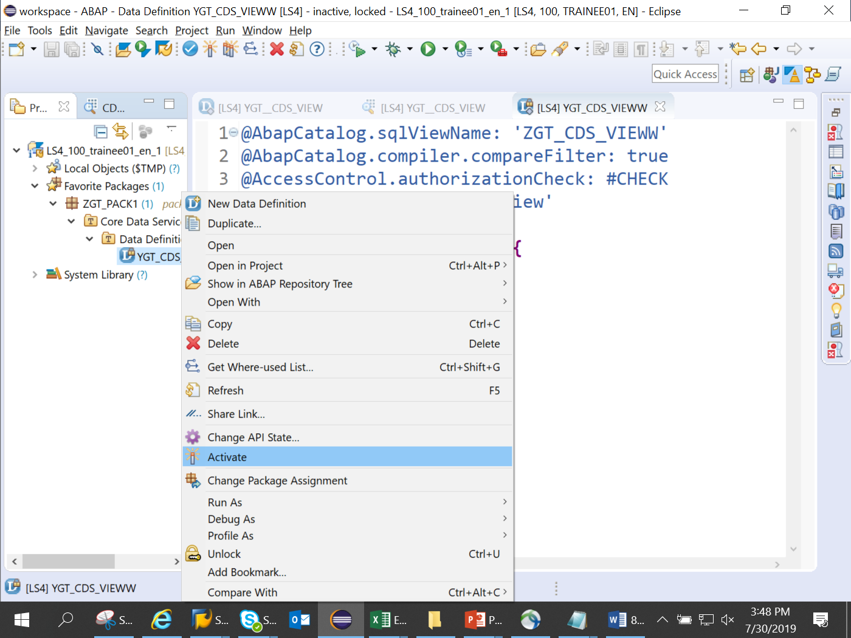

9) On sucessful activation, you will notice two objects are created below the view YGT_CDS_VIEW

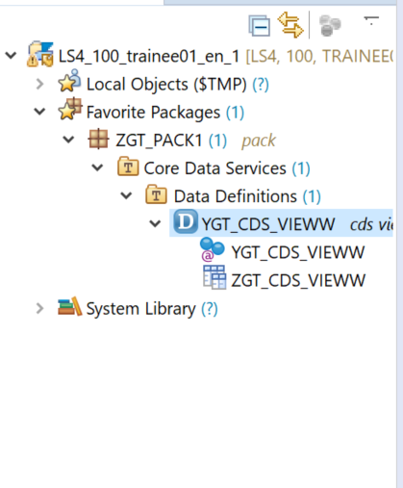

run as abap applciation

10. Right click on view- Runas-Abap application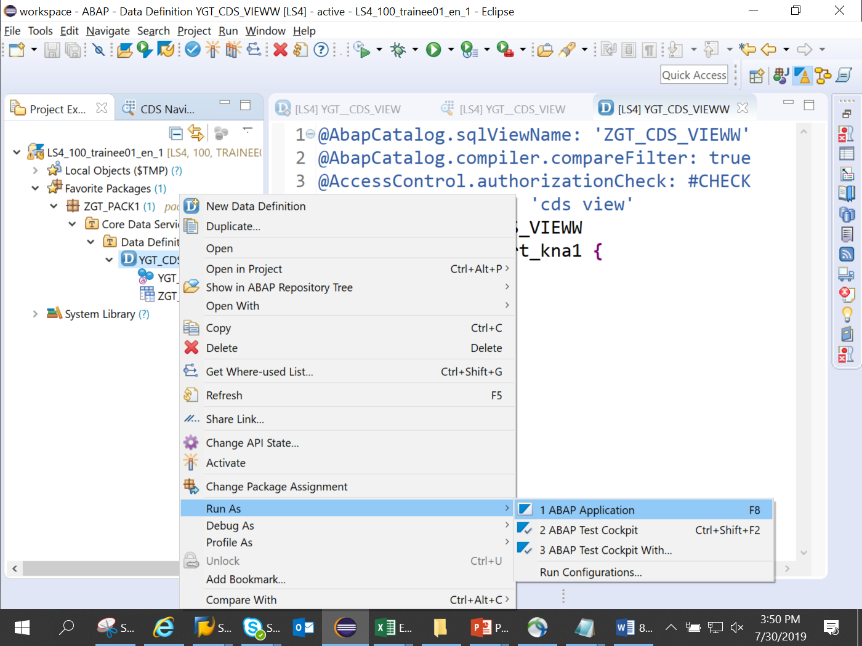

10..Output is as below

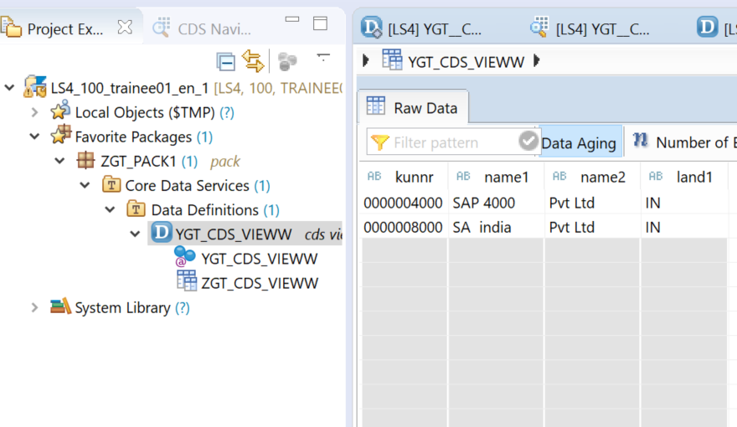

9) Create Se38 program and call the CDS view by writing below code’

REPORT ZTR_CDS_VIEW.  
  
  SELECT  *  
  FROM ZGT_CDS_VIEW  
  
  INTO TABLE @data(IT_SALES) .  
  cl_demo_output=>display( it_sales ) .

10) Output is

